**Black History Brain Bowl Team**

**Sponsor: Mrs. R. Wood**

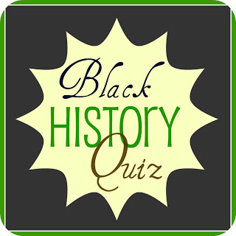

**"Success is to be measured not so much by the position that one has reached in life as by the obstacles which he has overcome while trying to succeed." - Booker T. Washington**

The Montford Black History Brain Bowl Team motivates students to embrace their African American heritage. The competition is formatted in trivia-style questions with factual answers pertaining to all levels of African-American history, literature, music, art, etc. At the yearly competition, students respond to various questions requiring a team of five students with two alternates selected to compete against other middle school teams in Leon County. According to Pegasus.com, the overall, the Black History Brain Bowl:

* Expands knowledge of Black history and culture
* Increases study skills and comprehension
* Inspires team spirit and camaraderie
* Motivates students to contribute to their heritage in positive ways
* Each student will receive a team T-shirt (5)

Practice is held every other Monday at 8:30 am in Mrs. Wood’s classroom, 6-114. Each student will receive a “study packet” in September; the competition is held in February.

Please join us for the first meeting September 1st

PERMISSION FORM

Name:_______________________________ Grade:_________

START Teacher:_______________________

3rd Period Teacher:______________________ 3rd Pd Subject:______________

Lunch: 1st 2nd 3rd

Cut Along the Line

I give my child, ______________________________ permission to participate in the Black History Brain Bowl Team. I will support my child’s study efforts at home and ensure he or she gets to/from the competition in February. The location TBA.

Parent Name:__________________________ Date:_____________________

Parent Signature:______________________ Phone:____________________

Student Signature:_____________________ Phone:____________________

If you have any questions, please call R.Wood, Sponsor at 922-6011 or email me at [www.woodr2@leonschools.net](http://www.woodr2@leonschools.net)

Thank You,

Mrs. R. Wood, Sponsor